Part 2: Practical Exploration of ILP Techniques
In this part we are executing a basic program using the default CPU model in gem5 and collecting the baseline performance metrics, which serves as a reference point for comparing more advanced CPU configurations in further steps.
# Baseline SimpleCPU
build/X86/gem5.opt configs/deprecated/example/se.py \
-c tests/test-progs/hello/bin/x86/linux/hello

# TimingSimpleCPU

build/X86/gem5.opt configs/deprecated/example/se.py \
--cpu-type=TimingSimpleCPU \
-c tests/test-progs/hello/bin/x86/linux/hello

# O3CPU with caches

build/X86/gem5.opt configs/deprecated/example/se.py \
--cpu-type=O3CPU \
--caches \
--l1d_size=16kB \
--l1i_size=16kB \
-c tests/test-progs/hello/bin/x86/linux/hello

# O3CPU with SMT

build/X86/gem5.opt configs/deprecated/example/se.py \
--cpu-type=O3CPU \
--caches \
--l1d_size=16kB \
--l1i_size=16kB \
--smt \
-c tests/test-progs/hello/bin/x86/linux/hello
#matplotlib script for CPI and IPC comparison:

import matplotlib.pyplot as plt

# CPU configurations
configs = ['SimpleCPU', 'O3CPU w/ Caches']

# CPI and IPC values
cpi = [2.085, 5.83]
ipc = [0.4796, 0.171]

# Plot CPI
plt.figure(figsize=(8,5))
plt.bar(configs, cpi, color='skyblue', label='CPI')
plt.ylabel('CPI (Cycles per Instruction)')
plt.title('CPI Comparison between CPU Configurations')
plt.show()

# Plot IPC
plt.figure(figsize=(8,5))
plt.bar(configs, ipc, color='salmon', label='IPC')
plt.ylabel('IPC (Instructions per Cycle)')
plt.title('IPC Comparison between CPU Configurations')
plt.show()

Simulation Setup
The simulation was executed using the following command:
build/X86/gem5.opt configs/deprecated/example/se.py \
-c tests/test-progs/hello/bin/x86/linux/hello

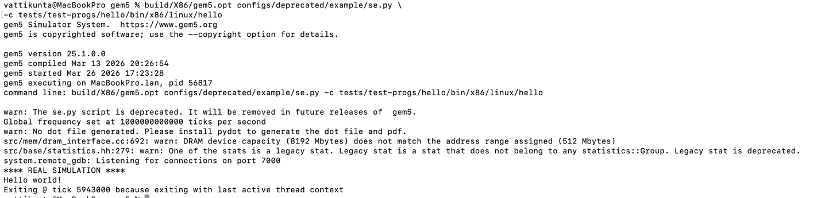

- build/X86/gem5.opt
→ Compiled gem5 binary for the X86 architecture.
- configs/deprecated/example/se.py
→ A system emulation (SE) mode script used to run user-level programs without a full operating system.
- -c tests/test-progs/hello/bin/x86/linux/hello
→ Specifies the executable program to run (a simple “Hello World” binary).

We used the above simulation due to the following reasons:
- This provides a minimal environment to test CPU behavior.
- It uses a simple workload to clearly observe pipeline performance.
- Establishes a baseline before introducing advanced features like ILP and SMT.
To confirm that the executable is available, we run the following command:
ls tests/test-progs/hello/bin/x86/linux/

This lists the files in the directory and ensures the hello binary exists before executing the simulation.

ls m5out/

The above command confirms the simulation is compiled successfully and confirms the presence of the output files as show above

cat m5out/stats.txt

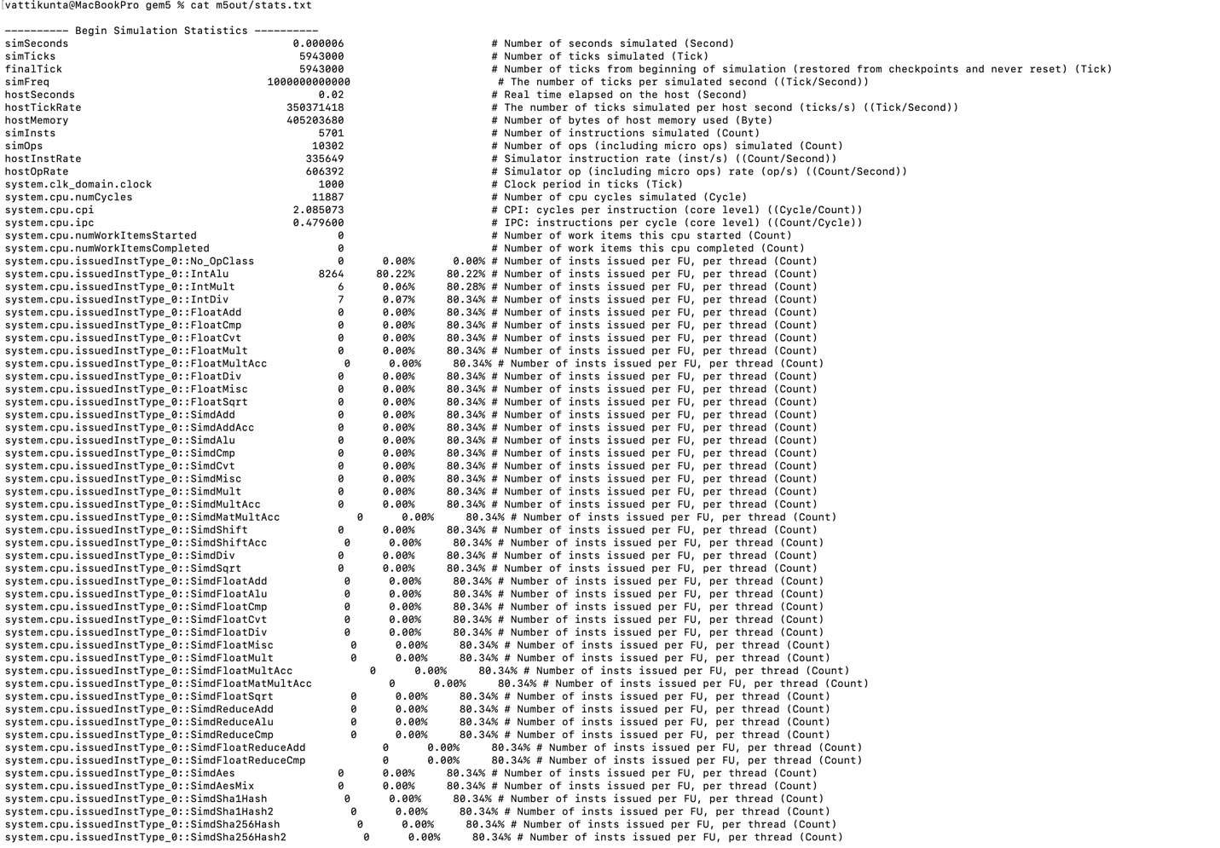
The above command displays the performance metrics generated by gem5 and provides key data such as:
- Total Instructions (simInsts) = 5701
- Total Cycles (numCycles) = 11887
- IPC = 0.4796
- CPI = 2.085

IPC =~ 0.48 (Low)
- Less than 1 → CPU is not fully utilizing pipeline which tells us the instructions are not executed all cycle and pipeline stalls are happening

CPI = 2.08 (High)
- Ideally → CPI ≈ 1
- ours → 2+ → inefficiency exists

Performance Metrics Analysis
In this step, we have evaluated the performance of simulated pipeline by using instruction throughput (IPC) and cycles per instruction (CPI). The simulation is executing total 5701 instructions, and it took 11887 cycles. So, based on these values, we are observing that IPC is coming approximately 0.48 and CPI is around 2.08 only.
This relatively low IPC is indicating that processor is not fully utilizing its pipeline, because on average, less than one instruction is getting completed per cycle. This is suggesting that some pipeline inefficiencies are there, like stalls happening because of instruction dependencies or maybe limited instruction-level parallelism in the workload.
Similarly, the CPI value is greater than 1, which means multiple cycles are required for executing each instruction. This is expected only in basic pipeline configuration because we are not using any advanced optimizations like branch prediction or out-of-order execution. So, these results are highlighting the limitations of simple pipeline and showing that we need ILP techniques for improving the performance.
Additionally, the workload is primarily consisting of integer operations only. We can see this from the high percentage of integer ALU instructions in the statistics. This is suggesting that there is no diversity in instruction types, so opportunities for parallel execution is becoming very less.
build/X86/gem5.opt configs/deprecated/example/se.py \
--cpu-type=TimingSimpleCPU \
-c tests/test-progs/hello/bin/x86/linux/hello

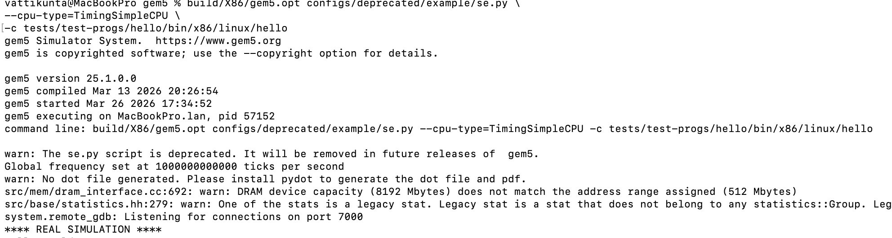

Explanation of Options
Option | Meaning
--cpu-type= TimingSimpleCPU | In-order CPU with detailed timing model

Why we need to TimingSimpleCPU?
- It provides a more accurate representation of real CPU behavior compared to SimpleCPU.
- Captures pipeline stalls and memory delays.
- Helps evaluate how timing effects impact CPI and IPC.
- Acts as a bridge between:
  - SimpleCPU (idealized)
  - O3CPU (advanced out-of-order execution)
cat m5out/stats.txt

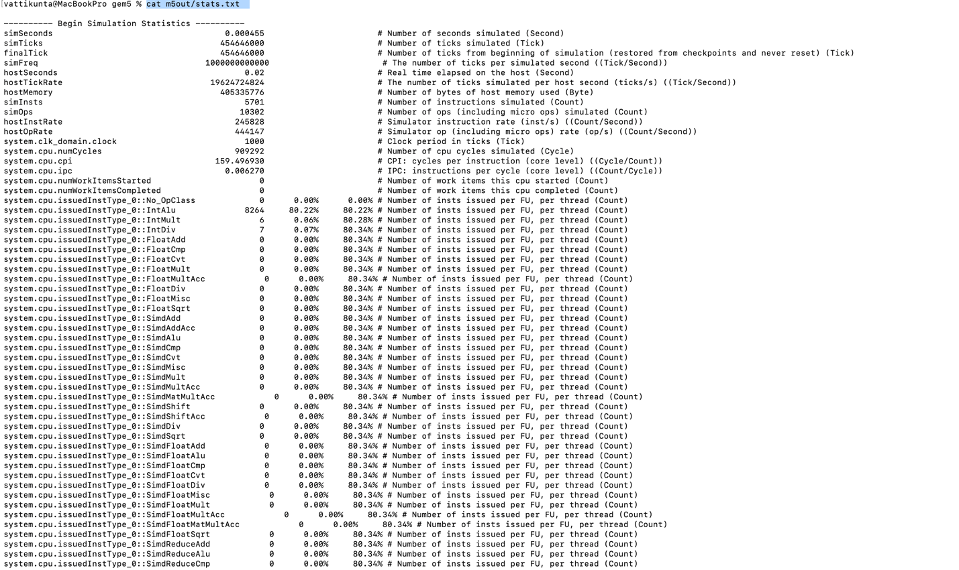
Key Statistics from Simulation (stats.txt):
- Simulated Time: 0.000455 seconds
- CPU Cycles: 909,292 cycles
- Instructions Executed: 5,701 instructions
- CPI (Cycles per Instruction): 159.50
- IPC (Instructions per Cycle): 0.0063

Performance Analysis
The results show a significant drop in performance efficiency compared to the baseline:
- IPC ≈ 0.0063 (Extremely Low): The CPU is executing far less than one instruction per cycle.
- CPI ≈ 159.5 (Very High): Each instruction requires many cycles to complete

Reason for High CPI and Low IPC
- Detailed Timing Model
  - Unlike SimpleCPU, this model simulates:
    - Pipeline stalls
    - Memory access delays
    - Instruction dependencies
- Small Workload
  - The Hello World program has:
    - Very few instructions
    - Minimal instruction-level parallelism (ILP)
  - This prevents efficient pipeline utilization
- Pipeline Initialization Overhead
  - A significant number of cycles are spent in:
    - CPU setup
    - Instruction fetch and decode stages

Conclusion:
The TimingSimpleCPU model demonstrates how realistic timing effects significantly impact CPU performance. The high CPI and low IPC highlight the cost of pipeline delays and memory latency, especially for small workloads. This step emphasizes that accurate CPU modeling introduces overhead, which becomes more noticeable when instruction-level parallelism is limited.

Simulation Setup with caches
build/X86/gem5.opt configs/deprecated/example/se.py \
--cpu-type=O3CPU \
--caches \
--l1d_size=16kB \
--l1i_size=16kB \
-c tests/test-progs/hello/bin/x86/linux/hello

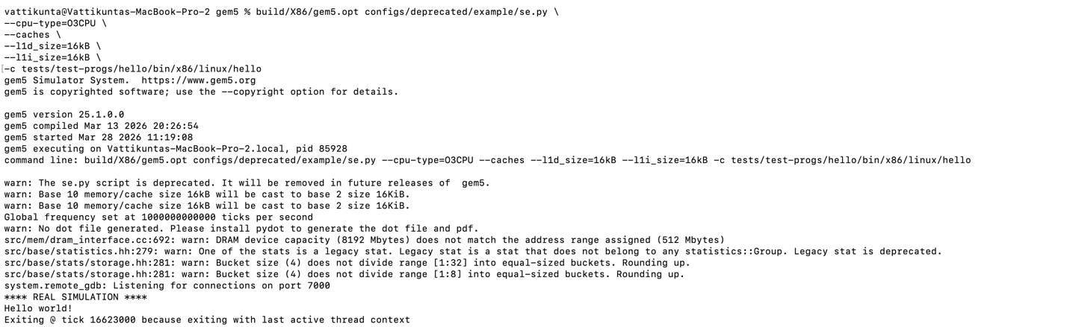
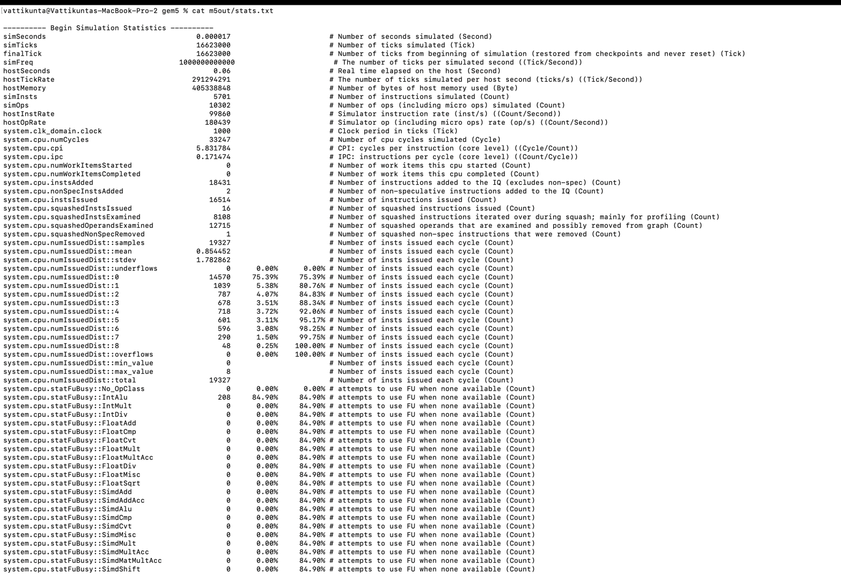

Key Metrics
- Instructions = 5701
- Cycles = 33,247
- CPI = 5.83
- IPC = 0.171
Compared to the previous step (TimingSimpleCPU without caches):
- CPI reduced from ~159.5 → 5.83
- IPC increased from ~0.0063 → 0.171

Reason for Improvement
- Reduced Memory Latency: Cache memory significantly decreases the time required to fetch instructions and data.
- Fewer Pipeline Stalls: Faster memory access reduces waiting time in the pipeline.
- Improved Instruction Throughput: More instructions are executed per cycle as compared to the previous step.
This Indicates that up to 8 instructions were issued in a single cycle which suggests the system has the capability for higher instruction throughput, although the small workload limits consistent utilization.
numIssuedDist:max_value = 8

This is telling us that cache memory is playing a very critical role for improving the CPU performance by reducing the memory access delays and all. Even if we are not using out-of-order execution, just by enabling the caches, the CPI is getting significantly low and IPC is increasing also and the performance is still having some limits because of the lack of instruction-level parallelism in our workload. Therefore, only cache is not enough if the program is not having enough parallelism.

Multiple Issue and Instruction-Level Parallelism (ILP)
In this step, we have performed the simulation using O3CPU, which is one out-of-order processor, and it can exploit the instruction-level parallelism (ILP) by using multiple instruction issue. Unlike that previous in-order CPU models, this O3CPU is capable to execute many instructions simultaneously and it can reorder the execution also for improving the performance.
The simulation results are showing CPI of approximately 5.83 and IPC is coming 0.17. If we compare with TimingSimpleCPU in Step 3 where CPI was very high (around 159.5), then here CPI is reduced significantly. This is clearly showing the advantage of out-of-order execution and multiple issue capabilities for reducing the pipeline stalls.
But even now the IPC is staying below 1 only. This is suggesting that our small "Hello World" workload is not having enough parallelism to fully utilize the processor's actual capabilities. If we use real-world applications with more complex instruction streams, then the benefits of ILP will be coming much more pronounced.
Running the SMT Simulation
build/X86/gem5.opt configs/deprecated/example/se.py \
--cpu-type=O3CPU \
--caches \
--l1d_size=16kB \
--l1i_size=16kB \
--smt \
-c tests/test-progs/hello/bin/x86/linux/hello
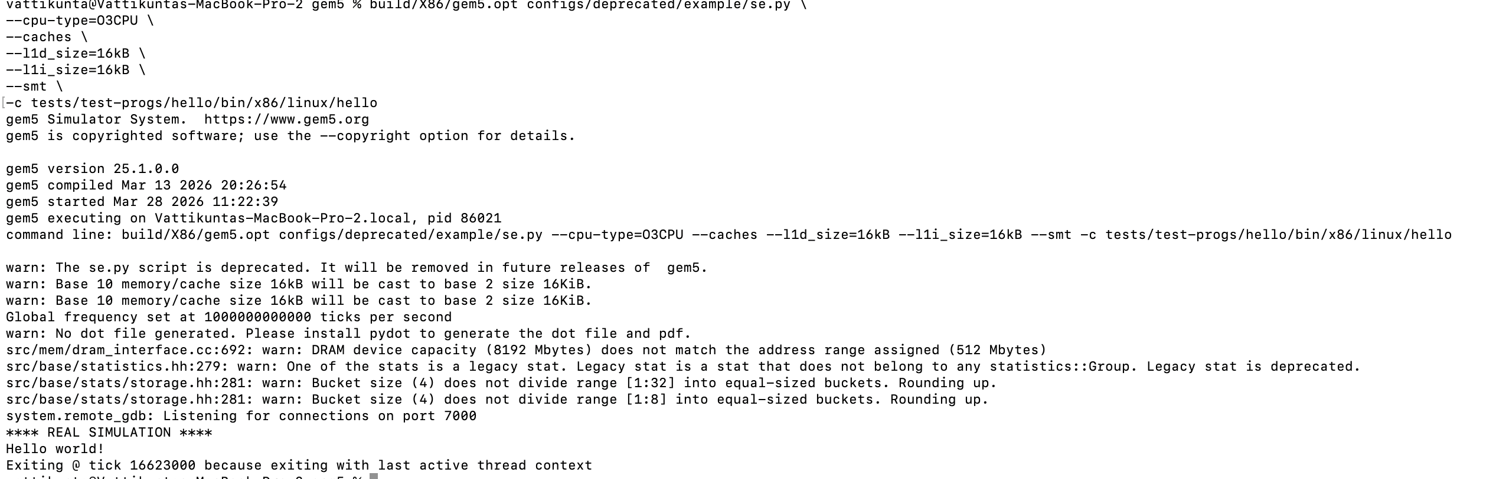

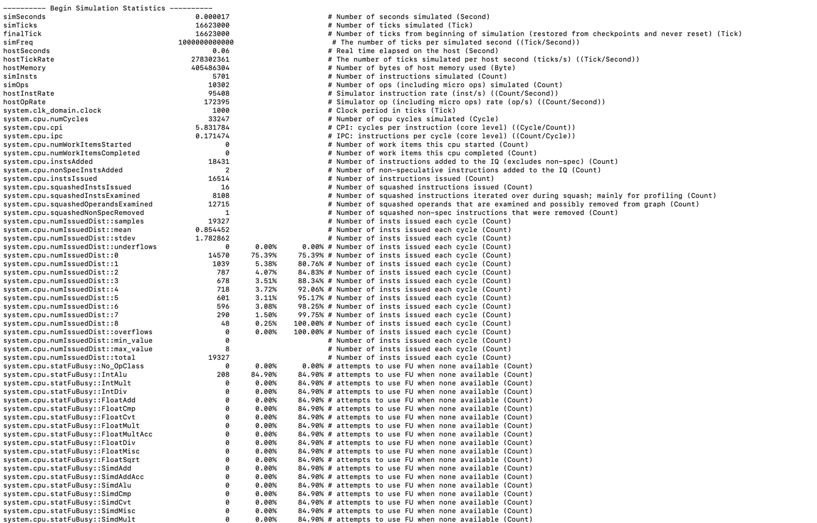
Based on the results we got:
- CPI = 5.83
- IPC = 0.171
We see there is no improvement due to the below reasons:
- The workload is single-threaded (hello)
- SMT needs multiple threads
- No additional threads → no extra utilization

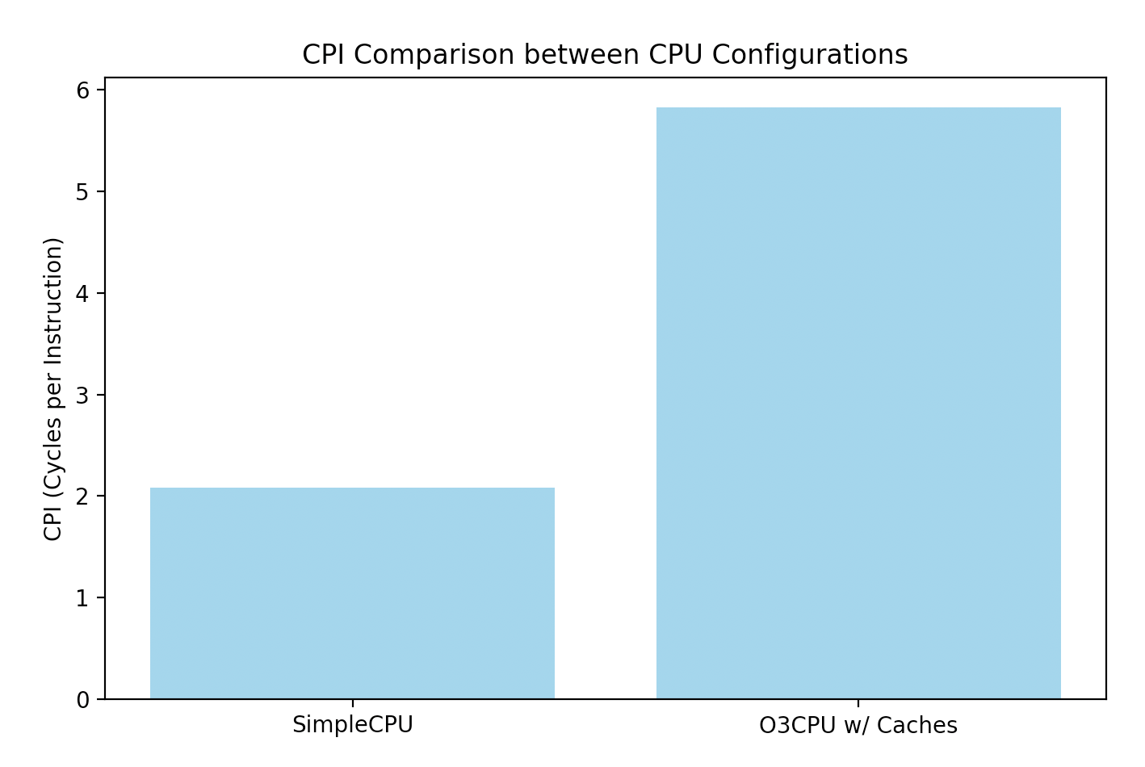

Comparison Table
CPU Type | Feature | CPI | IPC
SimpleCPU | Basic pipeline | 2.08 | 0.48
TimingSimpleCPU | Detailed timing | 159.5 | 0.006
O3CPU | ILP (multiple issue) | 5.83 | 0.17
O3CPU + SMT | Multithreading | 5.83 | 0.17
In this step, we have enabled the Simultaneous Multithreading (SMT) with O3CPU configuration for checking the performance impact. SMT is allowing multiple threads for sharing the CPU resources, so it will improve the utilization of execution units and increase the instruction throughput also.
But the simulation results are showing no change in CPI and IPC if we compare with previous step. The CPI is still coming same at 5.83 and IPC is also staying at 0.17 only. This is clearly indicating that SMT did not give any measurable performance improvement in this case.
The main reason for no improvement is the nature of the workload. Our Hello World program is having single-threaded nature only, so it is not providing multiple threads to the processor for executing at the same time. Because of this, the extra hardware resources which SMT is providing are just sitting idle and underutilized.
So, this experiment is proving that SMT is mostly effective for multi-threaded workloads only. There it can overlap the instruction execution from different-different threads and improve the overall processor throughput.

Overall Analysis of ILP Techniques
The experimental results are showing how different Instruction-Level Parallelism (ILP) techniques is impacting the processor performance. In basic pipeline, we are getting moderate efficiency only. But when we use detailed timing model, then CPI is becoming very high because of realistic pipeline delays and all.

By using the prebuilt Out-of-Order CPU (O3CPU), and suddenly CPI reduced too much. This is clearly highlighting the benefits of multiple instruction issue and dynamic scheduling. But one thing is there enabling SMT did not improve the performance at all. This is because our workload is having single-threaded nature only.

So, these results indicate that advanced ILP techniques like out-of-order and multithreading are working best when sufficient parallelism is there in the workload. For simple-simple programs, the overhead of complex CPU features will be more than the benefits. Therefore, workload characteristics is playing a very critical role for ILP optimizations. This study is showing that we must align the CPU architecture features with the workload to get the topper performance.

References:
1. Esmaeilzadeh, H., Blem, E., St. Amant, R., Sankaralingam, K., & Burger, D. (2011). Dark silicon and the end of multicore scaling. Proceedings of the 38th Annual International Symposium on Computer Architecture.
2. Hennessy, J. L., & Patterson, D. A. (2019). Computer architecture: A quantitative approach (6th ed.). Morgan Kaufmann.
3. Jiménez, D. A., & Lin, C. (2002). Dynamic branch prediction with perceptrons. Proceedings of HPCA.
4. Muchnick, S. S. (1997). Advanced compiler design and implementation. Morgan Kaufmann.
5. Shen, J. P., & Lipasti, M. H. (2013). Modern processor design: Fundamentals of superscalar processors. Waveland Press.
6. Stallings, W. (2018). Computer organization and architecture: Designing for performance (11th ed.). Pearson.
7. Sze, V., Chen, Y. H., Yang, T. J., & Emer, J. S. (2017). Efficient processing of deep neural networks. Proceedings of the IEEE.
8. gem5 Simulator. (n.d.). CPU models in gem5: SimpleCPU, TimingSimpleCPU, and O3CPU. Retrieved March 28, 2026, from https://www.gem5.org/documentation/general_docs/cpu_models

